**Project Planning Phase**

**Project Planning Template (Product Backlog, Sprint Planning, Stories, Storypoints)**

|  |  |  |
| --- | --- | --- |
| Date | 31October 2022 | |
| Team Id |  | PNTIBMNy52 |
| Project Name | Project -Smart Fashion Recommender Application | |
| Maximum Marks | 8 Marks | |

# Product Backlog, Sprint Schedule, and Estimation (4 Marks)

Use the below template to create product backlog and sprint schedule

|  |  |  |  |  |  |  |
| --- | --- | --- | --- | --- | --- | --- |
| **Sprint** | **Functional**  **Requirement (Epic)** | **User Story Number** | **User Story / Task** | **Story Points** | **Priority** | **Team Members** |
| Sprint-1 | User Panel | USN-1 | The user will login into the website and go through the products available on the website | 20 | High | A.AKSHAYA  P.AASHASATHYA  P.THARA  S.PRIYADHARSHINI |
| Sprint-2 | Admin panel | USN-2 | The role of the admin is to check out the database about the stock and have a track  of all the things that the users are purchasing. | 20 | High | A.AKSHAYA  P.AASHASATHYA  P.THARA  S.PRIYADHARSHINI |
| Sprint-3 | Chat Bot | USN-3 | The user can directly talk to Chatbot regarding the products. Get the recommendations based on information provided by the user. | 20 | High | A.AKSHAYA  P.AASHASATHYA  P.THARA  S.PRIYADHARSHINI |
| Sprint-4 | final delivery | USN-4 | Container of applications using docker kubernetes and deployment the application. Create the documentation and final submit the application | 20 | High | A.AKSHAYA  P.AASHASATHYA  P.THARA  S.PRIYADHARSHINI |

# Project Tracker, Velocity & Burndown Chart: (4 Marks)

|  |  |  |  |  |  |  |
| --- | --- | --- | --- | --- | --- | --- |
| **Sprint** | **Total Story Points** | **Duration** | **Sprint Start Date** | **Sprint End Date (Planned)** | **Story Points**  **Completed (as on**  **Planned End Date)** | **Sprint Release Date (Actual)** |
| Sprint-1 | 20 | 6 Days | 24 Oct 2022 | 29 Oct 2022 |  | 29 Oct 2022 |
| Sprint-2 | 20 | 6 Days | 31 Oct 2022 | 05 Nov 2022 |  | 05 Nov 2022 |
| Sprint-3 | 20 | 6 Days | 07 Nov 2022 | 12 Nov 2022 |  | 12 Nov 2022 |
| Sprint-4 | 20 | 6 Days | 14 Nov 2022 | 19 Nov 2022 |  | 19 Nov 2022 |

**Velocity:**

Imagine we have a 10-day sprint duration, and the velocity of the team is 20 (points per sprint). Let’s calculate the team’s average velocity (AV) per iteration unit (story points per day)

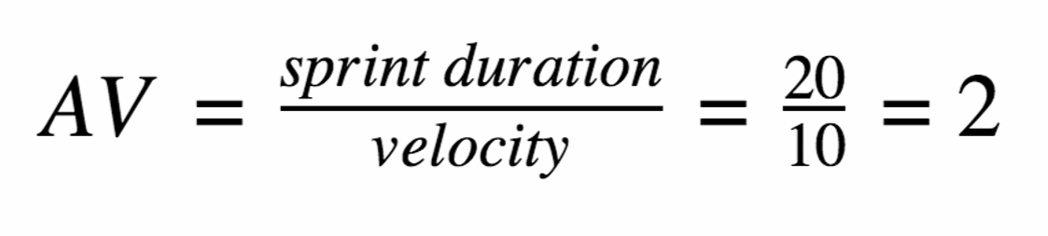

**Burndown Chart:**

